In the beginning of our website creation Abhi, Ciaran and I met up to plan out what website we would make, how it would work and what it would look like. We did this via Miro and made a general concept spider diagram planning out the different types of web pages we would have and where we could put things such as form validation and cookies.

After a while of discussion about different forms of e-commerce and e-business we eventually settled on making a car website that would allow a user to purchase or rent cars and that would include the ability to sign in and out and the ability to enter their card details.

As we wanted some inspiration to see how our website should be designed and how it should work, we all decided to look for car websites online to take screenshots of and examine them. This allowed us to see what features we liked and what features we didn’t like. Here are the screenshots:

After we had got our concepts in order, Ciaran created wireframes of what our pages should look like.

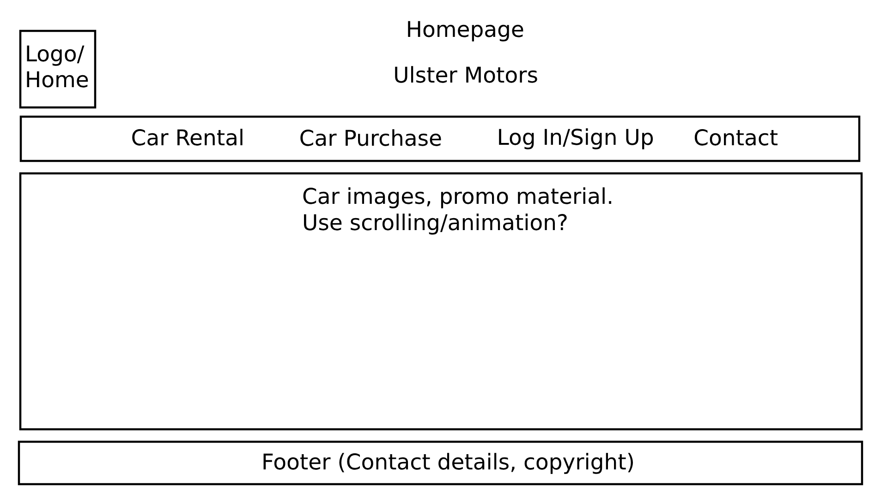

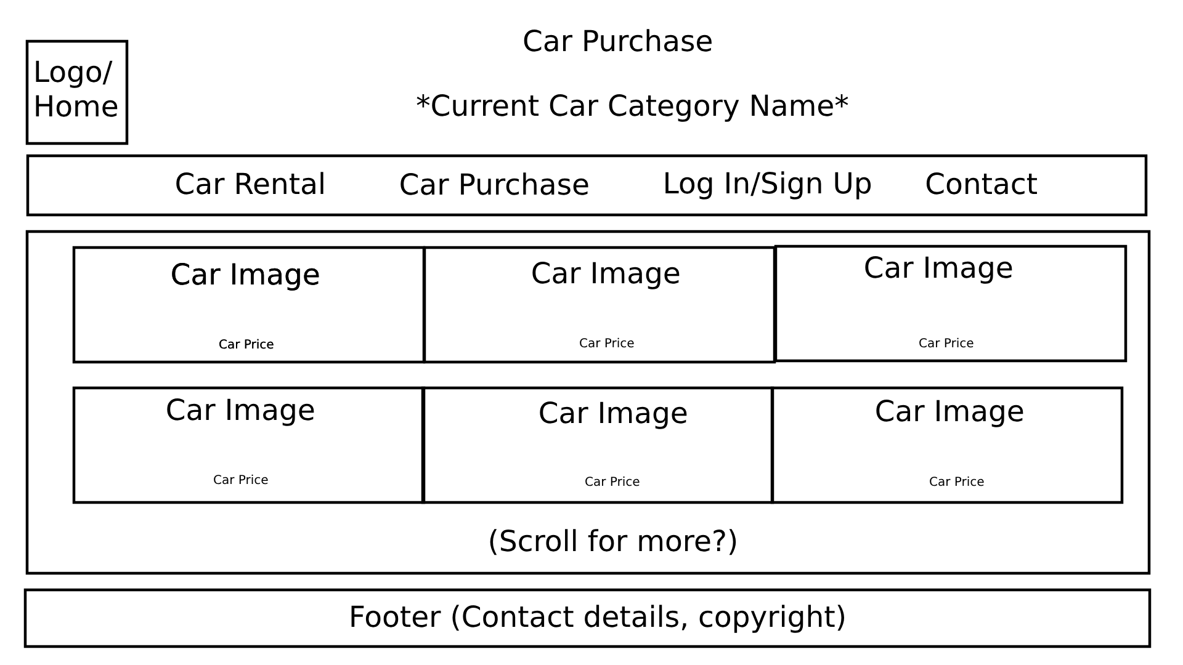

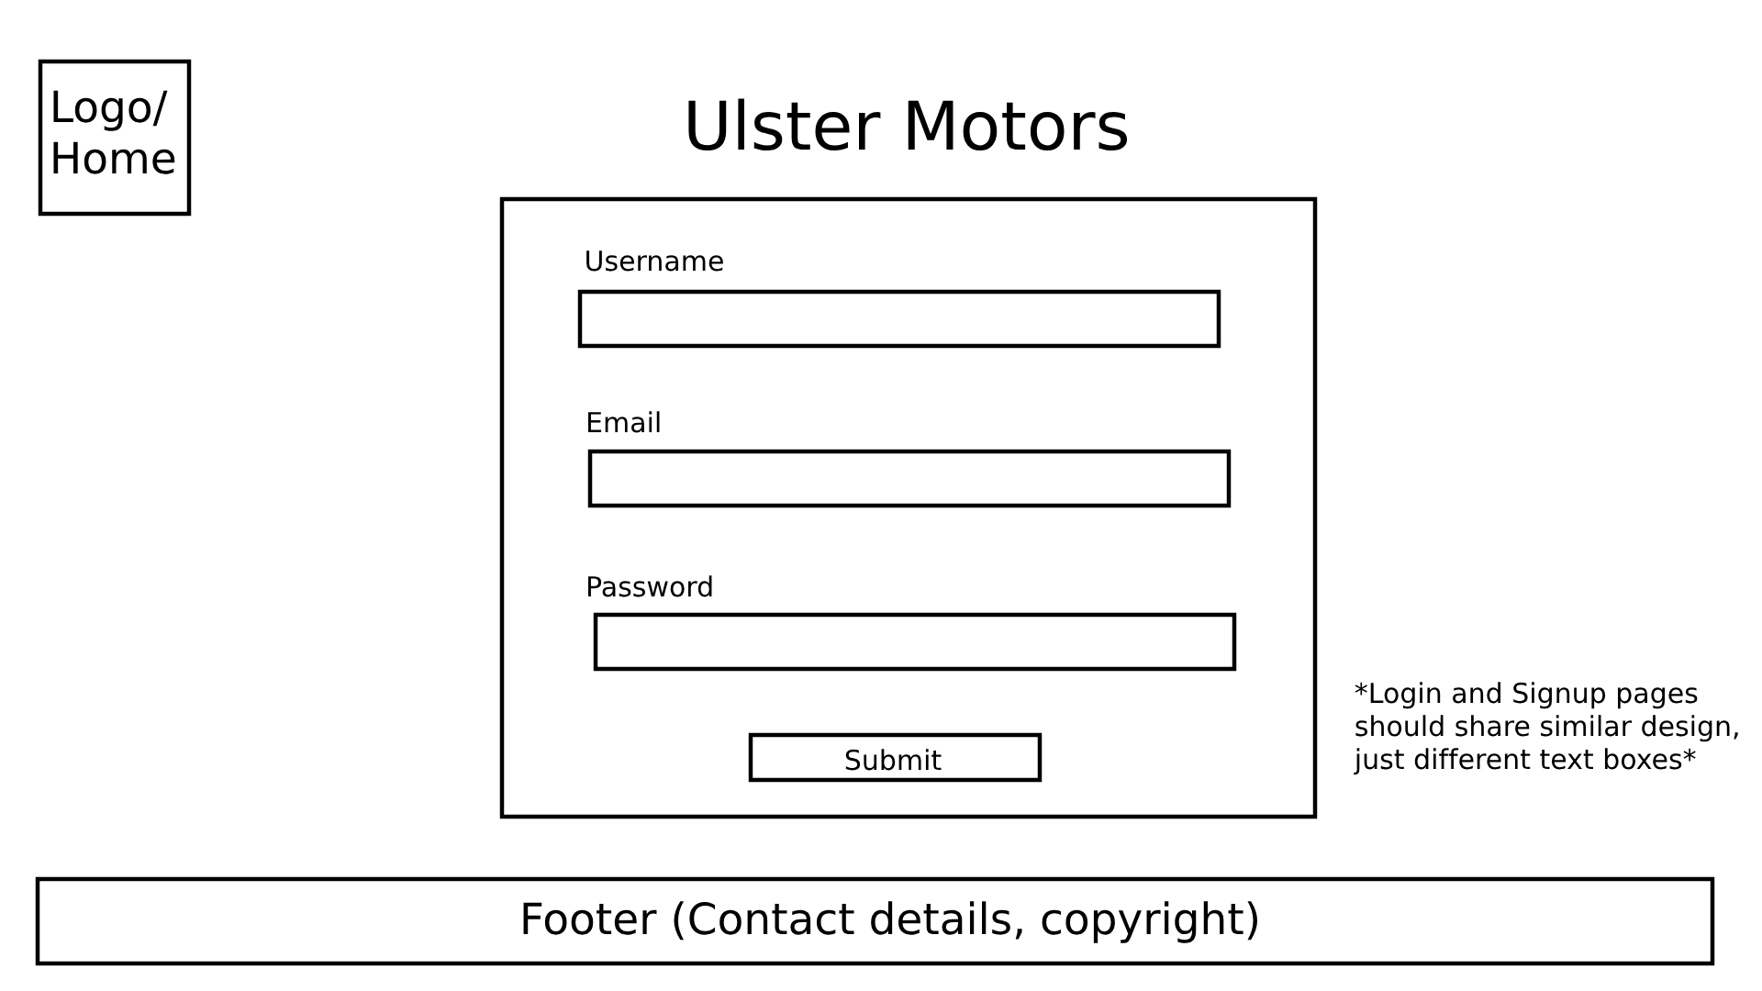

Abhi and Ciaran worked on creating the first prototype for our index. As I was not in their Monday class, I missed this meeting and created my own prototype index for the website. This was a prototype that included the main menu and dropdowns that would link to webpages that were yet to be created. This is what it looked like:

This took me a couple of days to fully make as I was new to HTML at the time. It also involved me using CSS which I also was unfamiliar with. This required researching HTML and CSS outside of class notes and slides and experimenting with what would work.

Finally, Abhi created the current index for our website including a main menu with dropdowns, initially a contact us button and a sign in button and including the initial prototype of the CSS for the index. This was good at helping users to navigate and would make it easier to look at for the user.

Next, as we would need to create a sign in page and add form validation to it, I researched how to do this and created a sign in page with rudimentary form validation to check that all the boxes had been filled, the email was valid, the password was over 6 characters, and that the username wasn’t empty. I implemented it but this would later be overhauled by Abhi with more complex form validation and the use of cookies.

Now that we had the dropdowns to different car types in both the car rental and car purchase part of our website, I looked at W3Schools (“CSS Image Gallery

“, W3Schools - <https://www.w3schools.com/css/css_image_gallery.asp> ) to see how to create a gallery and modified their code so that I could add in a gallery of cars that would later link to a description of the car if clicked on.

Now we had to add in photos to the main page so Abhi and I looked at creating a function that would be able to cycle between 3 different photos in the main menu. To make this we ended up using JSquery and so had to learn how to do this and use the language. It was new to us but we eventually began to get it to work.

For the next one or two weeks, Abhi, Ciaran and I worked on adding all of these webpages including 6 unique cars for each different section including:  
•Sedans: Electric, Hybrid and Petrol.

•SUVs: Electric, Hybrid and Petrol.

•Trucks: Electric, Hybrid and Petrol.

•New Cars: Electric, Hybrid and Petrol.

•Used Cars: Electric, Hybrid and Petrol.

•Luxury Cars: Electric, Hybrid and Petrol.

All of which included 6 unique cars with their own webpage that features a photo of them, their price at the top and their description.

I would add the information for the new cars, used cars and luxury cars all under car purchases and well as add all the information for the trucks and SUVs and electric sedans under car rental. This was a time consuming process as it would require changing the information for each and every webpage after researching cars to find ones that would match their description, e.g., finding 6 different cars that were electric and made in the past year. Then I would have to download an image of them, add their title and price (which I researched) then add their details in the linked webpage including a description, their name and price, a list of their make and model, body type, fuel type, engine and drive train as well as a list of their extra features and a shorter summary description. To do this I would use ChatGPT for their descriptions and lists. This required going through every webpage and copying the data in as well as making sure that the right photos were linked to the right pages and making sure that the go back button was linked to the right page and ensuring that all the rest of the data was correct.

This also included us getting photos of the cars we had on our website online and attempting to format them. This presented issues with photos being downsized and put into the 640x640px format that created a visual effect where some images looked stretched and pixelated. We would spend time attempting to fix this issue or at least make it less noticeable to a user, however, we did not get much success in doing this, finding that getting clearer photos was the solution.

Next, Ciaran and Abhi worked on entirely overhauling the css file and completing a redesign of the website. This included editing how the cars were displayed, how the dropdowns were displayed and also included adding a colour gradient to the dropdown buttons. This made the website look much more user friendly and professional.

While we were doing this, we worked on adding our logo, which was entirely designed and made by Ciaran, to the website, that would also bring the user back to the home page if clicked. This included us retroactively going through each and every webpage individually adding the logo and its link.

For this Ciaran had begun to redesign the logo to make it look more professional and more on brand. This had taken him a couple of days to do as there were multiple different mock ups and attempts. Here is the final product.

After we all agreed on this, the logo was implanted into the website in the place of the original logo.

At the same time, Ciaran would begin to work on the favicon so that the website would look more put together and professional. It was designed to look like car keys as Ciaran wanted to make something small due to him only having a very limited amount of pixels he could work with. This was the final result:



Abhi would also completely overhaul the sign in page, allowing the website to track via cookies whether the user was signed in or not. This would change whether the user could actually purchase a car or not. This is what allowed us to meet the requirement of using cookies in the website.

After adding this, Abhi would add in a complete a billing form in which the user would add their details and card details so that they could actually purchase a car, this would also include cookies storing their previously entered info and form validation confirming that everything was correct. For certain information that required dates, there are dropdowns allowing you to select which date you want, making it easier for a user to enter their details and not make a mistake.

After all the information for the website has been entered by Abhi, Ciaran and I, Abhi has remade the descriptions of cars: originally it was a paragraph, he has then added in different parts so that we also have bullet point summaries of the car’s make and model, body type, fuel type, engine and drive train and a bullet point list of its extra features. Then finally, he has completely overhauled this to add more detail to the car description so that it is clearer for a user.

Then we would begin to get our website in order by meeting up with each other and sorting out any differences and normalising the overall design, layout and information on the website. This was one of the biggest challenges as we were unorganised at the time.

After all the information was added to the website, Ciaran went through the folder and changed it so that every file would be in a folder and the storage would be neat as compared to how it was before hand were everything was loosely stored in one folder which made it very difficult to find files and would often lead to confusion. Then he went through and linked up every webpage to its folder’s location.

Finally, we performed testing on the final website. This included navigation and ensuring every link sent the user to where it should have and that there were no links leading to missing pages, and ensuring validation behaved as it should. We saved everything, backed it up and began to write our documentation.

Overall, this allowed us to learn more about how to use HTML, CSS and JSQuery and allowed us to understand how to create websites in a group setting were we all need to keep in sync and have an understanding of what each other person is doing and how we can help each other. This had presented a lot of difficulties, especially at the start, as it was difficult to gauge what each other person was doing. This made it very difficult to know what we should do and led to us making redundant webpages as someone else would also have made the webpage only for it to be written over.

If I were to make another website with a group like this in the future, I would ensure that we would remain in constant and consistent communication with each other and I would ensure that we were all certain on what we were supposed to be doing and what we were not supposed to do. This would help us to save time and would prevent us from having to cram it all at the very end despite having already done a sufficient amount of work at the very beginning.

References

Crawford Clarke - <https://www.crawfordclarkecars.co.uk/>- Homepage

Paul Blaney - <https://www.paulblaneymotors.com/>- Homepage

SERE Ltd - <https://www.seremotors.com/> - Homepage